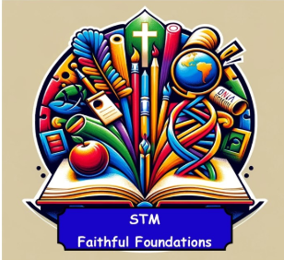 | Term 1 | Term 2 | Term 3 | Term 4 | Term 5 | Term 6
Reception | Class Reader  Harry and the bucketful of Dinosaurs – Ian Whybrow and Adrian Reynolds  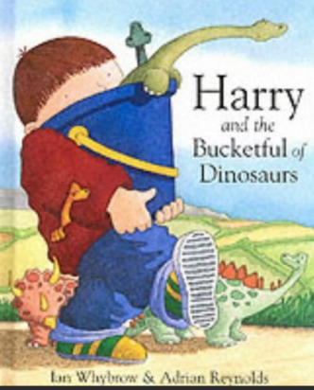 | Class Reader  Kitchen Disco – Clare Foges and Al Murphy  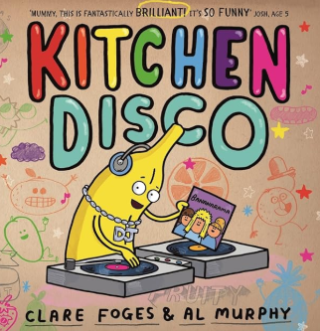 | Class Reader  Dogger - Shirley Hughes  - 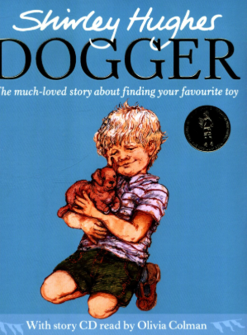 | Class Reader  Tree – Britta Teckentrup  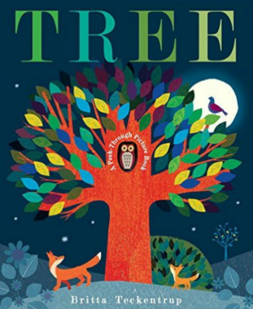 | Class Reader  The Very Hungry Caterpillar – Eric Carle  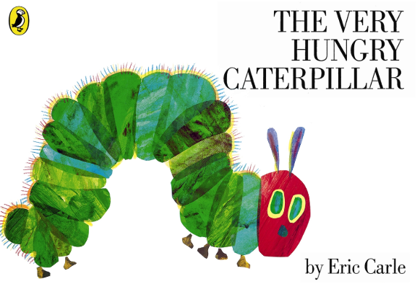 | Class Reader  Lifesize - Sophy Henn  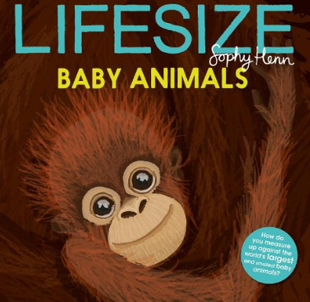
Year 1 | Class Reader  The Great Explorer –Chris Judge  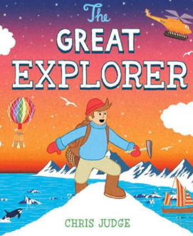 | Class Reader  Izzy Gizmo – Pip Jones  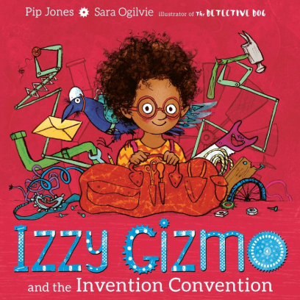 | Class Reader  The Queens Hat –  Steve Antony  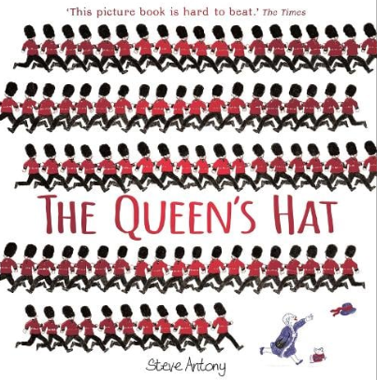 | Class Reader  The Bog Book Blooms - Yuval Zoomer  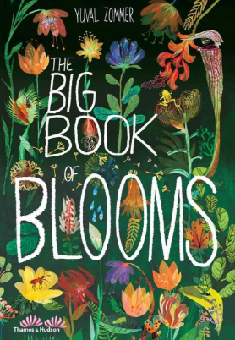 | Class Reader  Michael Recycle - Ellie Bethal  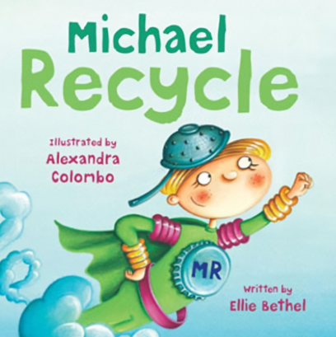 | Class Reader  Funny bones – Janet and Allen Ahlberg  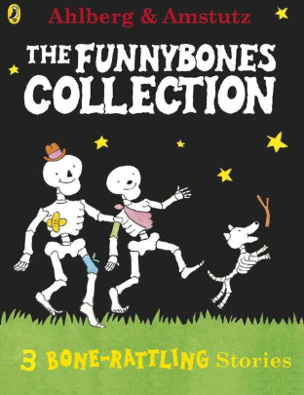
Year 2 | Class Reader  Treasure Island – Robert Louis Stevenson  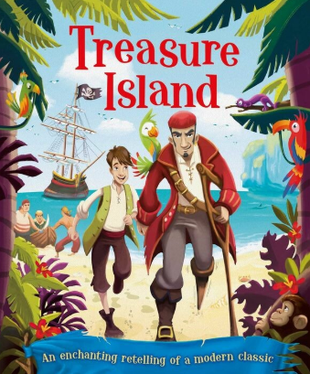 | Class Reader  The Gingerbread Girl -  Lisa Cambell Ernst  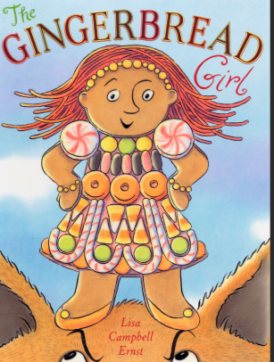 | Class Reader  Toby and the Great Fire of London – Margaret Nash  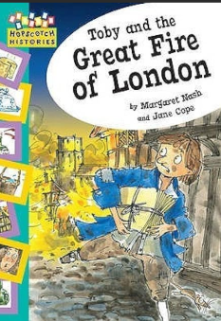 | Class Reader  The Way Back Home – Oliver Jeffers  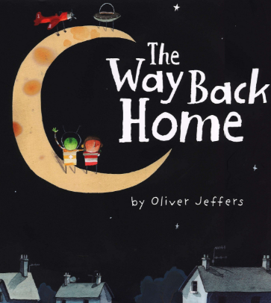 | Class Reader  The Hodgeheg – Dick King-Smith  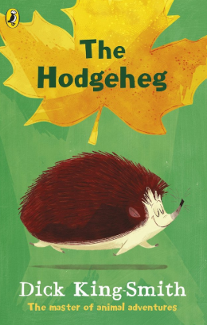 | Class Reader  Oscar and the Frog– Geoff Waring  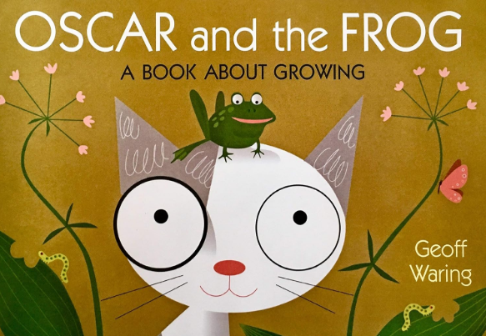
Year 3 | Class Reader  The Time travelling Cat and the Egyptian Goddess – Julia Jarman  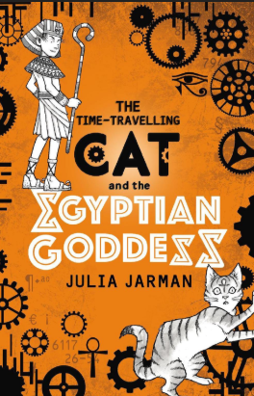 | Class Reader  The Iron Man - Ted Hughes  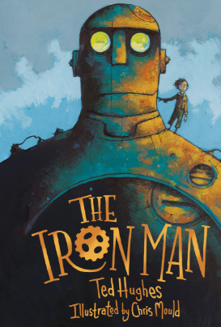 | Class Reader  Stone Age Boy – Satoshi Kitamura  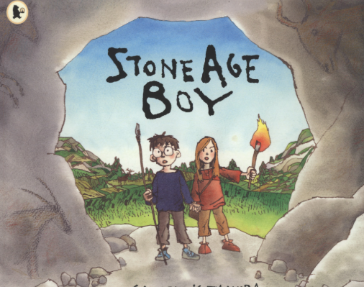 | Class Reader  Earth shattering events - Robin Jacobs  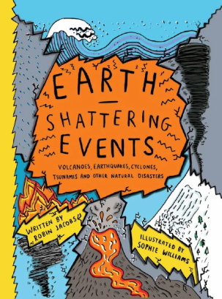 | Class Reader  The Last Bear – Hannah Gold  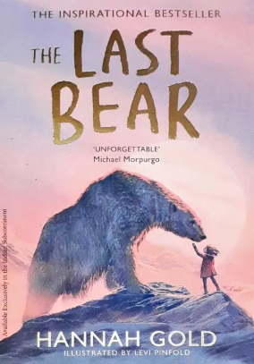 | Class Reader  Tin Forest – Helen Ward  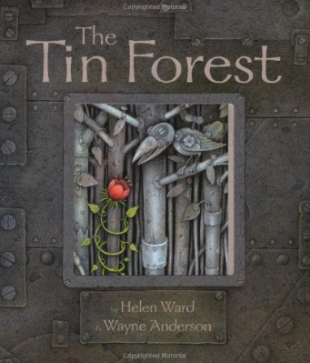
Year 4 | Class Reader  Who let the God’s out? - Maz Evans  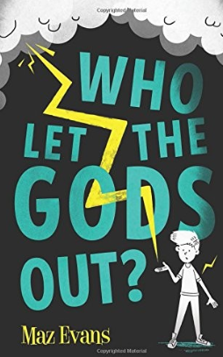 | Class Reader  Wonder – R.J Palacio  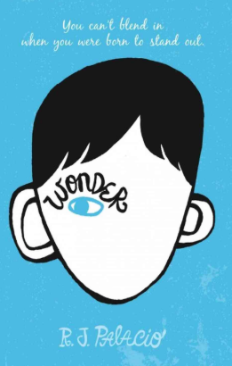 | Class Reader  Roman Diary: The Journal of Lliona, a Young Slave – Richard Platt  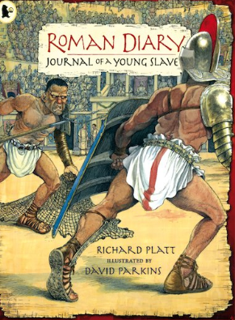 | Class Reader  Once upon a rain drop – James Carter  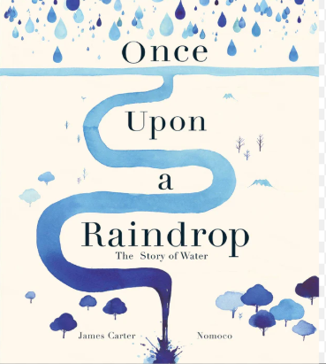 | Class Reader  A planet full of plastic –  Neal Layton  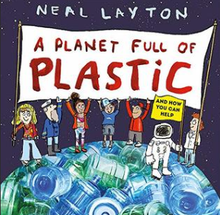 | Class Reader  Human Body Odyssey – Dominic Walliman and Ben Newman  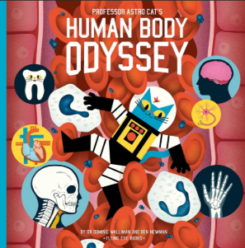
Year 5 | Class Reader  The curse of the Maya – Johnny Pearce and Andy Loneragan  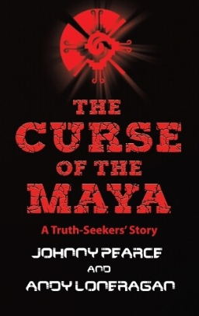 | Class Reader  Charlie and the Chocolate factory – Roald Dahl  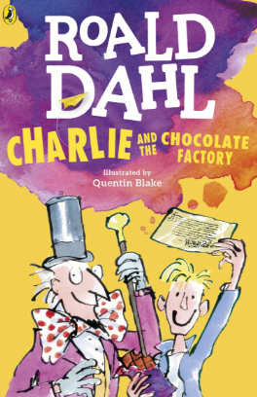 | Class Reader  Beowulf – Anonymous Author  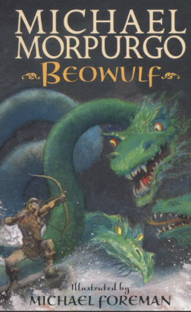  Viking Voyagers | Class Reader  The Great Kapok Tree – Lynne Cherry  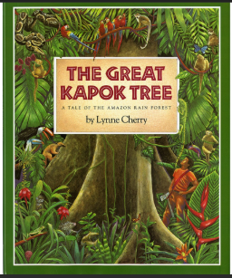 | Class Reader  The Explorer – Katherine Rundell  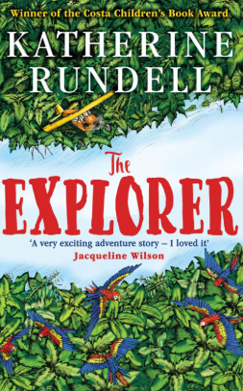 | Class Reader  The Jamie Drake Equation – Christopher Edge  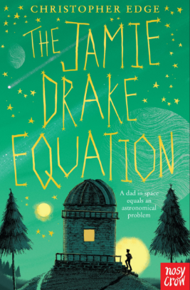
Year 6 | Class Reader  The Firework –Makers Daughter – Phillip Pullman  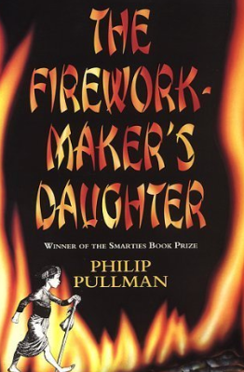 | Class Reader  A Christmas Carol  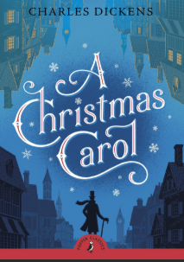 | Class Reader  Boy in the striped Pyjamas - John Boyne  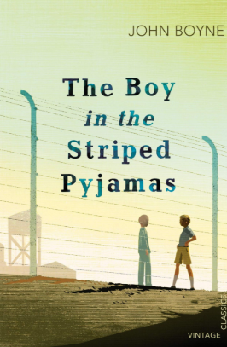 | Class Reader  Moth – Isabel Thomas  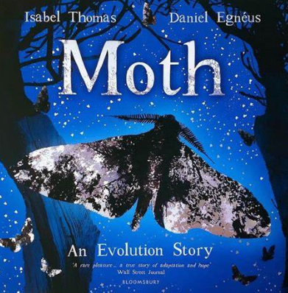 | Class Reader  Where the world turns wild – Nicola Penfold  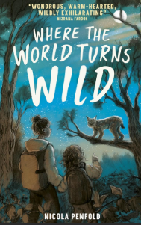 | Class Reader  Pig Heart Boy – Malorie Blackman  

