St Thomas More
Catholic Primary School

Home School Agreement

Inspiration, Celebration and Education

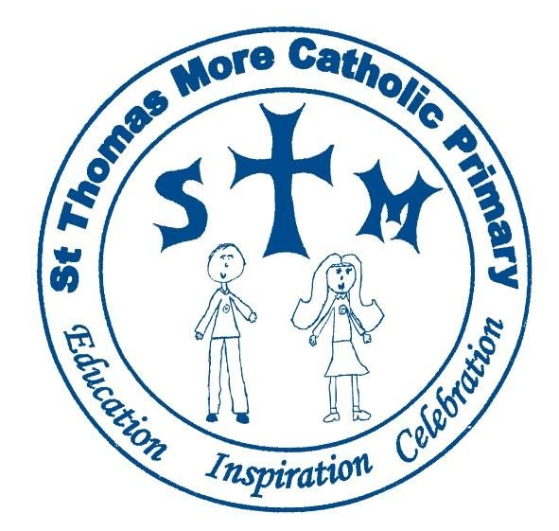

MISSION STATEMENT

I have come so that they may have life and have it to the full - John 10:10

As a Catholic school, God is at the heart of all we do. We believe that each person is made in His image, deserving to be treated with respect and dignity.

Showing respect, love and care for everyone and everything, we aim to develop harmony between pupils, parents, the school and Parish and grow as a Christian community.

We aim to embed the virtues in every child to believe in themselves to be the best that they can be and leave school as well-rounded individuals who care about themselves, others, and the world.

Contents | Page
Introduction | 3
Mobile Phones | 5
E-Safety | 6
Photographs | 7
Parents Copy (to keep) | 8
School Copy (to return) | 9
Consent Form for Photographs (to return) | 10

Introduction

We believe St Thomas More Catholic Primary School is a distinctive, inspiring and exciting place where children, parents, staff, governors and our community work together to provide a curriculum and learning environment that ensures every child achieves and makes the most of their talents given to them by God. By choosing to send your son/daughter to our school we have become your partners in the education and well-being of your child.

The purpose of this Home-School agreement is to give our Mission Statement a real context, whereby you as parents/carers, we as educators and your child as a pupil fully understand the purpose and respective responsibilities involved in being a member of our school community.

The school will ensure that:

- We care for your child’s safety and happiness.
- We will treat each child as an individual and with respect.
- We will provide your child with an education rooted in our Catholic ethos and core values.
- Your child achieves their full potential as a valued member of the school community.
- We provide a broad and balanced curriculum that meets the individual needs of your child.
- We achieve high standards of work and behaviour through building good relationships and developing a sense of responsibility.
- We will be open and welcoming at all times and offer opportunities for you to become involved in the daily life of the school.
- We will celebrate your child’s gifts and talents inside and outside of school.
- We will keep you informed of your child’s progress, and what you can do to support their learning at home.
The Parent/Carers:

Attendance
- I/We will make sure my child attends school punctually each day.
- I/We will inform the school on the first day of any absence at the latest by 9:30 am.
- I/We will ensure that regular, planned, expected medical appointments are made out of school time.
- I/We will ensure that family holidays are booked during school holidays. EXCEPTIONAL circumstances should be discussed with the Head Teacher following the completion of the absence request letter.

Parental Support
- I/We will attend parents’ consultation meetings and discussions on my child’s progress.
- I/We will make every effort to attend pastoral and curriculum meetings to support my child at home. e.g. Online learning, reading/phonics meetings, transition meetings, maths workshops etc.
- I/We will support my child with their homework, handing homework in on time.

Uniform
I/We will make sure that my child is properly presented for school by ensuring that :
- My child is wearing the correct uniform (labelled).
- My child has an appropriate hairstyle (NO shaved tramlines / patterns or colouring, undercuts or half-shaved hairstyles).
- My child is not wearing make-up or jewellery to school (stud earrings are acceptable but should not be worn in school during the day they have PE lessons/swimming).
- Any hair accessories are yellow and hair is tied back if long enough to do so.

Conduct/Behaviour
- I/We will support the school’s behaviour policy ensuring that pupils, staff and property are properly respected.
- I/We will keep the school informed of anything relevant that will affect my child in school.
- I/We will discuss any concerns or issues with school staff about my child with courtesy.
- I/We will not approach other people’s children to discuss matters involving my child.
- I/We will model a positive attitude towards education and the school and use discretion when discussing issues or grievances in front of children and other parents, as these may have a negative effect on their outlook.
- I/We will encourage our child to participate and support the faith of the School.

The Pupil:
I will:

- Be polite, respectful and helpful to others.
- Model our school’s core values every day.
- Keep the school rules.
- Attend school regularly and on time.
- Wear the school uniform and be tidy in appearance.
- Always do my best.
- Come prepared for lessons, eg. by having the correct PE kit, homework etc.

Mobile Phones

Due to safeguarding reasons, mobile phones are not allowed on school premises. Should you need to contact your child for any reason, the quickest way is to telephone school and the message will be passed on. If any phones are found in the cloakrooms, pockets, etc, they will be confiscated and parents will be asked to collect them from the office.

For children in Year 6 who walk home from school, they are allowed to bring a mobile phone into school. This phone must be turned off, given to the class teacher at the start of the school day and must not be used on the school premises.

E-Safety

Internet safety and being aware of the dangers present when using the internet is of paramount importance for our children. We all need to work together to ensure that our children are able to use the internet safely. The school uses apps and learning sites to support children’s learning. This will involve the use of your child’s name and date of birth. All information will be stored securely and follow GDPR policies. The apps and learning sites that the school currently uses are:

- Class Dojo
- Times Table Rock Stars
- IDL Interventions
- Learning Village
- Mathletics

The SCHOOL will:
- Promote e-safety through the curriculum, assemblies and e-safety days / weeks.
- Provide safe search engines for children to use in school and from home.
- Inform parents of any concerns we have regarding e-safety.
- Monitor any incidents relating to e-safety.
- Ensure any data kept on apps and learning sites is held securely.

The FAMILY will:
- Be aware of their social responsibilities with regard to using the internet and related technologies, including treating others with respect.
- Promote e-safety at home.
- Be mindful of social networking and be aware that many sites such as ‘Facebook’and ‘Tik Tok’, are not intended for children under the age of 13.

The CHILD will:
- Listen to and follow advice provided for their own safety when using the internet.
- Report any worries regarding e-safety to their parents and to the school.

Photographs

There have been rapid changes in the technology of image reproduction. Taking and publishing pictures are now easy and it can be difficult for schools to monitor and control images of children. St Thomas More Catholic Primary School has a duty to provide a safe environment for pupils at school. While we are aware of the risks of image misuse, we believe that the school needs to balance this against the positive value of professional, high quality images of pupils in celebrating and promoting the school as an enjoyable, colourful and vibrant place to learn. Good pictures of the school and its children can help in putting the school at the heart of the local community and enhance its reputation.
The SCHOOL will:
- Take photographs and videos of children for assessment and display purposes in school.
- Use photographs and video footage on the school website and in publications.
- Limit parent’s photography and video filming to designated areas.
- Ensure that children who should not be photographed, for example, those children whose parents have refused consent, are not included in any images.

The Parent/Carers will:
- Either give/not give permission for their child’s photograph to be taken.
- Contact school if they do not give permission for photographs or video footage of their child to be used in publications or on the school website.
- Only take images of their child participating in school activities for family and personal use.
- Not place images of their child participating in school activities on any public or social media sites.

We would like to take this opportunity to thank you
for your continuing support.

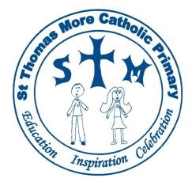
Home – School Agreement
Including: Mobile Phones, E-Safety & Photographs

Parent Copy

I/We the parent/carer of ………………………………………………………………….… declare that I/we have read the Home-School Agreement and are committed to upholding the principles outlined in it.

I/We will pay particular attention to my/our responsibilities as parents/carers.

PARENTS COPY
Head Teacher : Mrs K Turner

Signature : Date :

Parent’s Name :……………………………………………… Date :

Signature : ………………………………………………………

Pupil’s Name : ………………………………………………… Date :

Signature : ………………………………………………………

Please sign both copies and RETURN ONE COPY TO SCHOOL ASAP

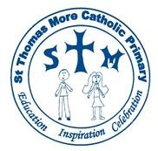
Home – School Agreement
Including: Mobile Phones, E-Safety & Photographs School Copy

I/We the parent/carer of ………………………………………………………………….… declare that I/we have read the Home-School Agreement and are committed to upholding the principles outlined in it.

I/We will pay particular attention to my/our responsibilities as parents/carers.

PARENTS COPY
Head Teacher : Mrs K Turner

Signature : Date :

Parent’s Name :……………………………………………… Date :

Signature : ………………………………………………………

Pupil’s Name : ………………………………………………… Date :

Signature : ………………………………………………………

Please sign both copies and RETURN ONE COPY TO SCHOOL ASAP

MEDIA CONSENT FORM

NAME OF CHILD : ………………………………..………………… CLASS: ……………………………

Occasionally, we may take photos of the children at our school. We use these images as part of our school displays and sometimes in other printed publications like the School Newsletter. We will also use them on our School website.
If we use photographs of individual pupils, we will only use their first name with accompanying text or photo caption.
From time to time, our School may be visited by the media who will take photographs or film footage of a high profile event. Children may appear in these images, which will sometimes be published in local or national newspapers, or on approved websites.
To comply with the General Data Protections Act (GDPR), we need your permission before we can photograph or make any recordings of your child.
Please answer the questions below, then sign and date the form where shown and return the completed form to the School.
Please circle your answer
I give permission for my child’s photograph to be used within school for display purposes. | Yes / No
I give permission for my child’s photograph to be used in the School Prospectus and other printed publications that we produce for promotional purposes. | Yes / No
I give permission for my child’s image to be used on our website. | Yes / No

I give permission for my child to appear in the media. | Yes / No
I give my permission for my child’s details to be used on learning sites to support their learning | Yes / No

Please note that the conditions for use of these photographs:

- This form is valid for the period of time your child attends this school. The consent will automatically expire a year after your child has left this school.
- We will not re-use any photographs or recordings a year after your child leaves this school.
- We will not use the personal details or full names (which means first name and surname) of any child or adult in a photographic image on video, on our website, in our School Prospectus or in any of our other printed publications.
- We will not include personal e-mail or postal address, or telephone numbers on media, on our website, in our School Prospectus or in any of our other printed publications.
- If we use photographs of individual pupils, we will not use the full name (which means first name and surname) of that child in the accompanying text or photo caption.
- We may include pictures of pupils and teachers that have been drawn by the pupils.
- We may use group or class photographs or footage with very general labels, such as ‘a science lesson’ or ‘making Christmas decorations’.
- We will only use images of pupils who are suitably dressed, to reduce the risk of such images being used inappropriately.
- Websites can be viewed throughout the world and not just in the United Kingdom where UK law applies.

I have read and understood the conditions of use.
Print Name: ……………………………………………… Date: …………………………………… Signature: ………………………………………………………………….
Relationship to child: .……………………………………………….

