KNOWLEDGE BASED
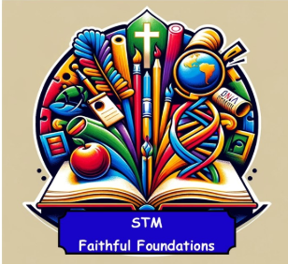 | Phonics Lesson | Units of Work | Links with the curriculum | Experience Days
Year 3 | Lesson 1 | I am Learning Spanish |  | 26th September – European Languages Day  W.C 13.10.2025 – Spanish Day (12th October)  W.C 23.02.2026 – International Mother Language Day (21st February)
Year 3 | Lesson 1 | Animals | Science
Year 3 | Lesson 1 | Instruments | Music
Year 3 | Lesson 1 | I know How To
Year 3 | Lesson 1 | Ice - Cream
Year 4 | Lesson 2 | Presenting Myself |  | 26th September – European Languages Day  W.C 13.10.2025 – Spanish Day (12th October)  W.C 23.02.2026 – International Mother Language Day (21st February)
Year 4 | Lesson 2 | My Family
Year 4 | Lesson 2 | At the Café
Year 4 | Lesson 2 | In the Classroom
Year 4 | Lesson 2 | What is the Weather? | Geography
Year 5 | Lesson 3 | The Date |  | 26th September – European Languages Day  W.C 13.10.2025 – Spanish Day (12th October)  W.C 23.02.2026 – International Mother Language Day (21st February)
Year 5 | Lesson 3 | Do you have a pet?
Year 5 | Lesson 3 | My Home
Year 5 | Lesson 3 | The Olympics | PE
Year 5 | Lesson 3 | Clothes
Year 6 | Lesson 4 | At School |  | 26th September – European Languages Day  W.C 13.10.2025 – Spanish Day (12th October)  W.C 23.02.2026 – International Mother Language Day (21st February)
Year 6 | Lesson 4 | Planets | Science
Year 6 | Lesson 4 | At the Weekend | RSE
Year 6 | Lesson 4 | Me in the World

