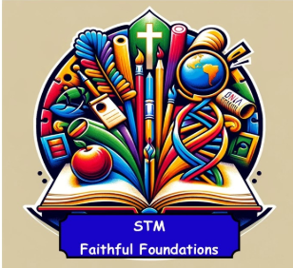 | 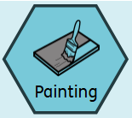  Painting/ Printing | 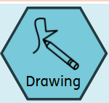  Drawing | 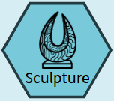  Sculpture | 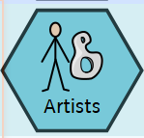  Knowledge of Artist | 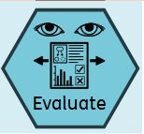  Evaluating and Analysing
Reception | Identify and name primary colours (Red, Blue, Yellow)  Use brushes, fingers or sponges to apply paint  Create simple prints using body parts  Express personal experiences and imagination through paint | Hold and use drawing tools with increasing control  Investigate patterns when drawing  Investigate how to make large and small movements with control when drawing  Making observations and looking carefully at objects  Combining materials when drawing | Pinch, roll, and shape malleable materials  Attach simple forms (roll aball and attach it)  Create 3D forms inspired by observations or imagination  Use basic tools such as lolly sticks, plastic cutting tools, safely  Begin to describe texture and shape of their sculpture  Playdough sculptures | Henri Matisse -  Colour and Shape  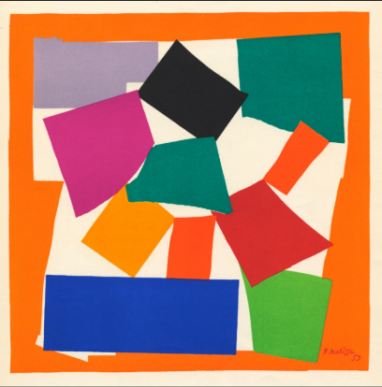 | Begin to talk about their own artwork and others using simple descriptive language  Express likes and dislikes  Begin to describe colour , shapes, or marks used  KEY Focus:  Encouraging vocabulary and confidence in talking about what they see
Year 1 | Identify and name primary and secondary colours (Red, Blue, Yellow, Green, Purple, Orange)  Mix primary colours to make secondary colours  Explore techniques using a paint brush e.g. blending, splatter, or resist methods  Create simple prints using everyday objects E.g. Leaves, potatoes, stamps  Express personal experiences and imagination through paint | Draw simple shapes and objects from observations  Begin to notice basic details in objects like size, shape, textures  Use simple patterns and textures e.g. dots, dashes to add details  Complete a line drawing | Attach simple forms (roll a ball and attach it)  Create 3D forms inspired by observations or imagination  Use basic tools such as lolly sticks, plastic cutting tools, safely  Begin to describe texture and shape of their sculpture  Clay sculptures | Kandinsky –  Abstract art and Emotions in colour  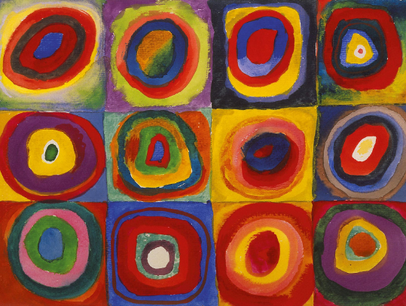 | Describe what you see in art using key terms such as line, shape and colour  Express personal opinions (I like this because…)  Talk about how art makes them feel  Begin to compare different artists  KEY Focus:  Observing and describing using basic art language
Year 2 | Identify and name primary and secondary colours  Mix colours with white and black to make shades  Use a paint brush to create textures and effects  Create simple prints stencils  Express personal experiences and imagination through paint | Use different types of lines with control  Draw from real life objects, noticing shape, texture and proportions  Begin to shade to show texture  Experiment with different pressures to make tone | Compare materials that could be used for sculpture  Look at materials that can be used for joining materials  Create sculpture designs  Use simple shapes to represent 3D forms e.g. circles for head  Add basic details to a sculpture  Natural Sculptures | Andy Goldsworthy –  Natural Art/Outdoor learning  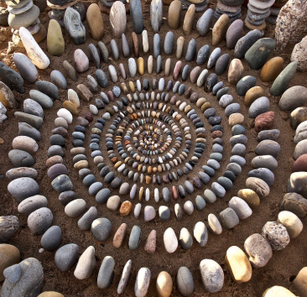  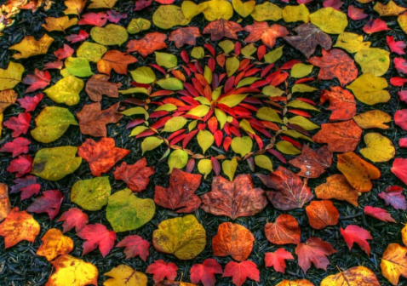 | Describe what you see in art using key terms such as line, shape and colour  Express personal opinions (I like this because…)  Talk about how art makes them feel  Begin to compare different artists  KEY Focus:  Observing and describing using basic art language
Year 3 | Mix primary and secondary colours to make tertiary colours  Use a variety of painting tools for different textures and effects  Create repeating patterns using print block or stencils  Express imagination, personal style, creativity and uniqueness through painting | Understand and create tone it in a drawing  Achieve even tones when shading  Make careful observations to accurately draw an object  Create an abstract composition to draw more expressively | Explore materials that can be used for sculpture  Plan and create a sculpture based on a theme  Create ways of strengthening forms  Add surface decoration to a sculpture  Junk Model sculptures | Jean Michel – Basquiat  Street art and expression  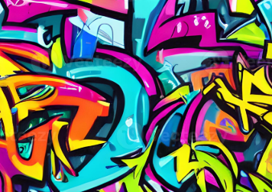  Banksy  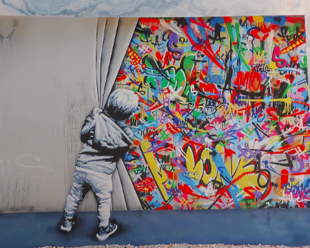 | Use specific art terms (e.g. textures, tone, pattern and composition)  Explain choices in your own work ( I used dark colours to show mood)  Begin to evaluate the effectiveness of techniques used in their own and others work  Make comparisons between artists or artwork (Style, colours, themes)  KEY focus –  Justifying opinions and using appropriate terminology
Year 4 | Explore shades of colour to create light and dark  Use different paints to create texture and style  Create repeating pattern prints incorporating texture (string, bubble wrap, textured fabrics)  Express imagination, personal style, creativity and uniqueness through painting | Apply one and shading using light and shadow  Draw from Observation, memory and imagination with a focus on proportion and space  Recording ideas, practicing techniques and reflecting this in final designs  Study and replicate techniques from an artist | Plan and design sculpture through drawings  Consider structure and scale  Combine shapes to make more complex forms  Add details using tools and layering  Link sculptures to themes or artists  Papier mache | Claude Monet - Impressionism and light  Water lilies  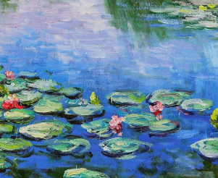 | Use specific art terms (e.g. textures, tone, pattern and composition)  Explain choices in your own work ( I used dark colours to show mood)  Begin to evaluate the effectiveness of techniques used in their own and others work  Make comparisons between artists or artwork (Style, colours, themes)  KEY focus –  Justifying opinions and using appropriate terminology
Year 5 | Use warm/cool, contemporary colours intentionally  Explore layering techniques  Design and carve simple blocks e.g. foam. Lino, cardboard  Create multi-step prints and paintings based on themes  Express imagination, personal style, creativity and uniqueness through painting | Experiment and use techniques like blending, smudging and layering to create 3D effects  From observation, accurately represent shape, scale and proportion  Annotate recoded ideas and sketches with reflections and next steps  Use art vocabulary to critique and improve drawings | Plan and design sculpture through drawings that can be reviewed and adapted  Refine initial ideas through self feedback  Consider structure and scale  And material properties  Use tools with greater accuracy and independence  Discuss work using appropriate vocabulary e.g. form, structure, balance, Abstract  Build a sculpture using a range of materials  Wire and foil sculptures | Vincent Van Gogh –  Texture and Brushstrokes  Starry Night  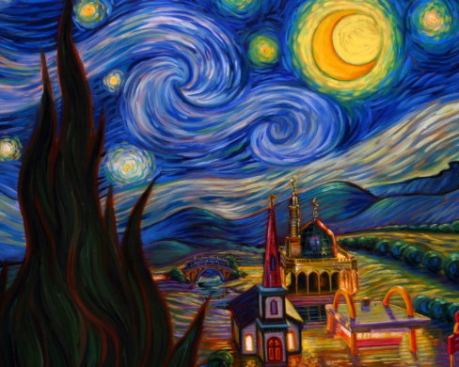 | Use detailed art vocabulary confidently and accurately  Reflect on how an artwork communicates meaning or emotion  Critically evaluate their own wok and suggest specific improvement  Analyse and compare artists techniques, intentions and context ( time period and culture  Show awareness of how an audience or purpose influences artwork  KEY focus –  Independent reflection, thoughtful critique and understanding of meaning
Year 6 | Use colours intentionally to create mood  Explore layering, resist, and blending techniques  Design and carve print blocks that are layered e.g. foam. Lino, cardboard  Create multi-step prints and paintings based on an artist  Express imagination, personal style, creativity and uniqueness through painting | Choose specific tools to achieve specific effects  Apply advance shading techniques such as tonal gradients, cross hatching to create 3D effects  Apply one point or two point perspective to add depth to composition  Produce detailed, expressive drawings from life and photographs | Plan and design structures inspired by a theme, emotion, music  Refine initial ideas through self and peer feedback  Add texture, pattern and surface decoration with purpose  Discuss work using appropriate vocabulary e.g. form, structure, balance, Abstract  Modroc sculptures | Andy Wahol -  Colour and contrast  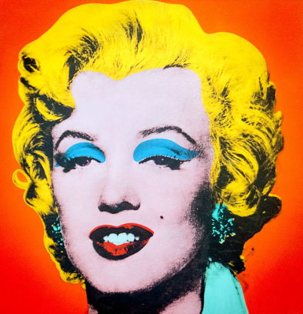  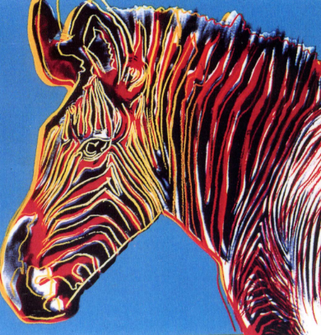 | Use detailed art vocabulary confidently and accurately  Reflect on how an artwork communicates meaning or emotion  Critically evaluate their own wok and suggest specific improvement  Analyse and compare artists techniques, intentions and context ( time period and culture  Show awareness of how an audience or purpose influences artwork  KEY focus –  Independent reflection, thoughtful critique and understanding of meaning
Knowledge | Elements of Art  - Line - Types of line (straight, curved, zigzag) line to outline shapes or add details  - Shape and form – Geometric vs organics shapes , 2D, 3D  - Colour – Primary, Secondary, Tertiary, warm, cool, mixing colours, tints and shades  - Texture – Real (touchable) and visual texture , creating texture with materials  - Tone – light/dark, shading, using tone to show depth and mood  - Space – foreground, middle, background, overlapping, and size and depth  - Pattern – Repetition, symmetry, tessellation, decorative and cultural patterns  Materials and techniques  - Drawing – use of pencil, charcoal, crayons, sketching, shading, crosshatching  - Painting – Watercolour, poster paints, brushwork, colour mixing  - Printing – mono-printing, block printing, using stencils, repeating patterns  - Sculpture – Building with clay, paper, junk, wire, foil, joining techniques, 3D planning  - Collage – Cutting, tearing, layering materials, combining  Art Appreciation and Vocabulary  - Talk and respond to their own and others art work  - Recognise the work of key artists  - Use terms like line, texture, abstract, mood, composition, technique, materials  Art History  - Understand that art is created in different times and places  - Compare and contract styles  - Learn about traditional crafts from other cultures  Creative Thinking  - Use imagination and observations to generate ideas  - Plan artwork using sketches  - Make artistic choices and explain them  - Evaluate their work and think about improvements

