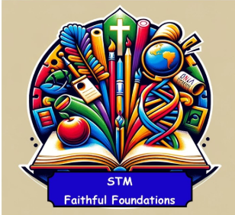 | Key Concepts  - Printing is the process of transferring paint or ink from one surface to another to create patterns, textures, or images.  - Techniques include mono-printing, block printing, stencilling, and repeating patterns.  - Printing supports creativity, pattern-making, and expression across all year groups.  Art Elements in Printing  - Line – outlines and details in prints.  - Shape – geometric and organic forms.  - Colour – mixing, layering, and contrasting.  - Texture – tactile and visual effects.  - Pattern – repetition and symmetry.  - Tone – light and dark areas for depth.  Creative Thinking & Evaluation  - Plan and sketch ideas before printing. | - Make artistic choices about colour, texture, and pattern.  - Reflect on how printing communicates mood or meaning.  - Evaluate techniques and suggest improvements.  - Compare styles and intentions of different artists  Artists  - Henri Matisse – Known for bold colour and shape; simple cut-outs inspire early printing Make artistic choices about colour, texture, and pattern.  - Paul Klee – Used simple shapes and colour; accessible for early printing exploration  - Andy Goldsworthy – Natural materials and patterns; inspires nature-based printing  - William Morris – Famous for decorative repeating patterns and block printing  - Albrecht Dürer – Renaissance printmaker known for detailed woodcuts  - Katsushika Hokusai – Japanese artist known for woodblock prints like The Great Wave  - Andy Warhol – Pop artist famous for screen printing and bold colour contrast
 | ART | Key Vocabulary
Reception | Create simple prints using body parts (e.g. handprints).  Explore paint using brushes, fingers, sponges. | Print, colour, sponge, finger, handprint, pattern, mark
Year 1 | Create prints using everyday objects (e.g. leaves, potatoes, stamps).  Explore resist methods  Primary colours, secondary colours, stamp, resist, texture, object, pattern | Primary colours, secondary colours, stamp, resist, texture, object, pattern
Year 2 | - Create prints using simple stencils.  - Mix colours with white/black to create shades. | Stencil, shade, mix, light/dark, repeat, shape, outline
Year 3 | - Create repeating patterns using print blocks or stencils.  - Mix colours to create tertiary colours. | Tertiary colours, block print, stencil, repeat, pattern, texture
Year 4 | - Create repeating pattern prints using textured materials (e.g. string, bubble wrap).  - Explore light and dark shades. | Texture, bubble wrap, string, repeat, pattern, shade, contrast
Year 5 | Design and carve simple blocks (foam, lino, cardboard).  Create multi-step prints based on themes. | Foam, lino, carve, layer, multi-step, press, transfer
Year 6 | - Design and carve layered print blocks.  - Use layering, resist, and blending techniques.  - Create prints inspired by artists. | Layering, resist, blend, contrast, composition, print block, edition

