 | 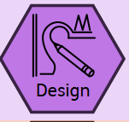  Design | 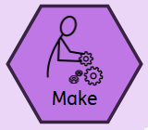  Make | 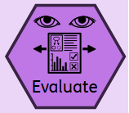  Evaluate | 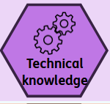  Technical Knowledge | 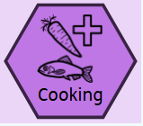  Cooking and Nutrition
Reception | Understanding the World:  Explore how things work (e.g., simple machines, everyday objects).  - Talk about what they see and how things are used  - Exploring and Using Media and Materials:  - Use a variety of materials, tools, and techniques to design and make products.  - Experiment with colour, design, texture, form, and function. | Physical Development:  Develop fine motor skills through cutting, joining, and manipulating materials. Use tools safely and with increasing control.  - Expressive Arts and Design:  - Safely use and explore a variety of materials, tools, and techniques. Represent their own ideas, thoughts, and feelings through design and technology, art, music, dance, role-play, and stories.  Bird Feeder  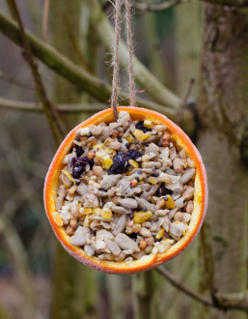 | Communication and Language:  Develop technical vocabulary (e.g., cut, join, fold, build).  Explain their ideas and describe what they are doing or have made  Junk Model Toy  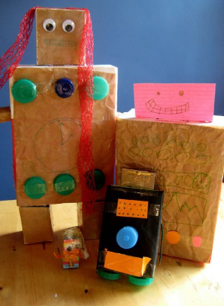 | Scissors, Glue, Tape, String, Paper, Cardboard, Fabric, Wood, Plastic, Clay, Junk modelling  - Cut, Stick, Fold, Join, Build, Make, Design, Create, Draw, Decorate, Assemble, Mix, Roll, Shape  - Hard, Soft, Rough, Smooth, Bendy, Strong, Weak, Heavy, Light, Shiny, Dull  Christmas Biscuit  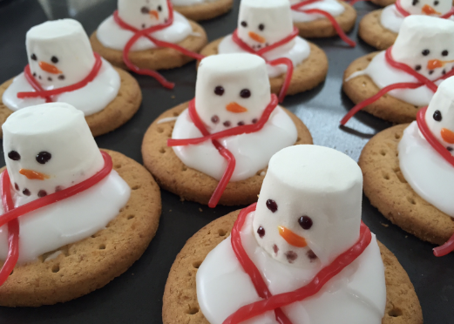 | - Develop independence and confidence in trying new foods  - Follow simple instructions and routines.  - Use cooking-related vocabulary  - Talk about what they are doing and describe textures, smells, and tastes.  - Develop fine motor skills (e.g., stirring, pouring, kneading).  - Practice hygiene routines like washing hands and cleaning up.  - Learn about where food comes from.  - Explore changes in materials (e.g., melting, mixing, baking).  - Talk about healthy eating and food choices.
Year 1 | Generate ideas through drawing and talking  Begin to design purposeful , functional products based on simple design criteria  Use pictures and words to plan , focusing on who the product is for and what it will do | Select and use a range of tools and equipment (e.g. scissors, glue, hole punch) safely  Choose materials based on their properties (e.g. bendy, strong, waterproof)  Begin to join materials using basic techniques (e.g. glue, tape, folding)  Castles  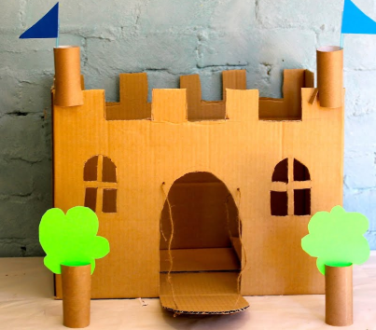 | Explore and evaluate a existing products (e.g. tools and tools)  Say what they like or dislike about the product  Begin to evaluate their own work against simple criteria (Did it move? Did it stay together?) | Build simple structures and explore how they can be made stronger  Explore basic mechanisms such as Levers, sliders  Sliding Christmas Cards  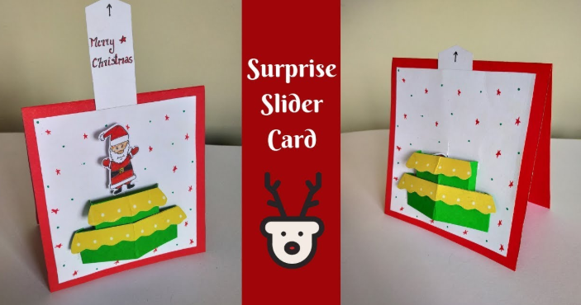 | Understand that some foods are healthy and unhealthy  Begin to prepare simple dishes (e.g. fruit salad)  Learn how to use tools safely (knives with supervision)  Fruit Salad  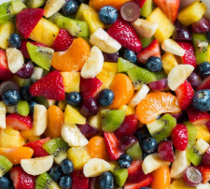
Year 2 | Develop design ideas through labelled drawings, templates, and mock ups  Consider purpose and user more explicitly when planning products  Begin to use IT or templates for design work | Select a wide range of tools and materials, including textiles and basic construction kits  Use tools more precisely (e.g. measuring. Cutting along lines)  Combine materials in more complex ways (e.g. gluing, stitching, fixing, wheels to axels  Tudor Houses  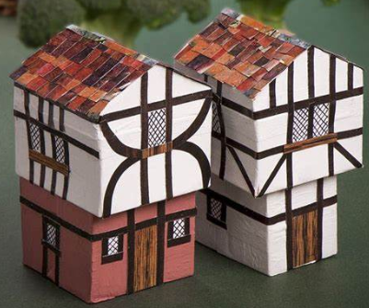 | Compare finished products to design ideas  Identify strengths and ways they can improve their products  Evaluate how well products meet the needs and purpose | Understand how to make structures stronger, stiffer an d more stable  Use wheel and axels in products that move (e.g. toy cars)  Understand how simple mechanisms work (e.g. moving parts in a book)  Farm Vehicle  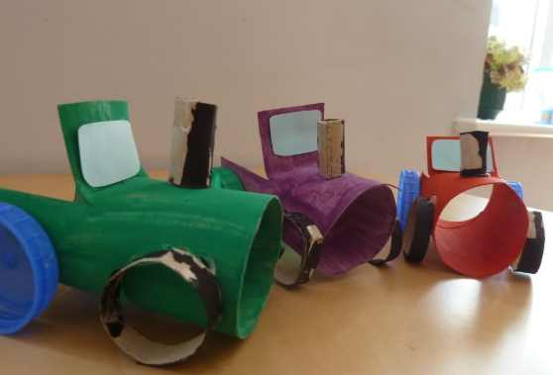 | Understand where food comes from (e.g. farm to fork)  Learn to combine ingredients in a simple recipe  Follow basic hygiene rules when preparing food  Gingerbread  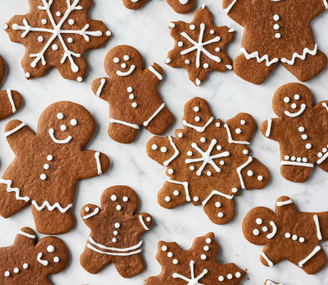
Year 3 | Use research to develop ideas for functional products  Communicate ideas using annotated sketches and prototypes  Plan a sequence of actions to make a product | Select from a range of materials and tools for specific tasks  Use tools (Saws, glue guns, hole punch) with accuracy and control  Begin to measure , mark, cut and join with some accuracy  Magnet fishing game  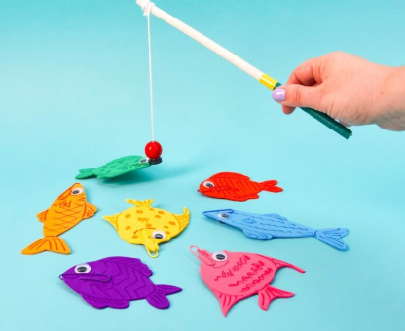 | Evaluate their product against their own design criteria  Begin to consider how existing products meet users’ needs  Suggest improvements to their to their own and others work | Understand how to strengthen and reinforce structures  Explore simple mechanical systems e.g. levers and switches  Use basic electrical components (bulbs, buzzers, switches )  Stone Age Shelters  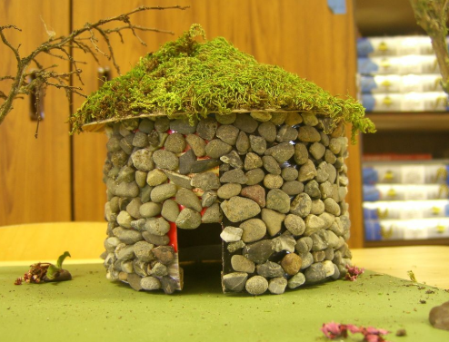 | Understanding food groups and begin planning balanced meals  Learn basic cooking techniques (e.g. peeling, chopping)  Understand the importance of Hygiene and food safety  Smoothies  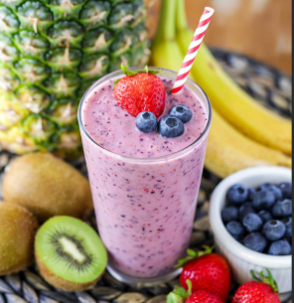
Year 4 | Develop ideas using prototypes and pattern pieces  Consider aesthetics, purpose and function in their designs  Use IT to enhance or model their design work | Measure, mark cut and assemble materials accurately  Use a wide range of joining techniques e.g. sewing, gluing, combining materials  Choose appropriate tools and explain their choices  Roman Aqueduct  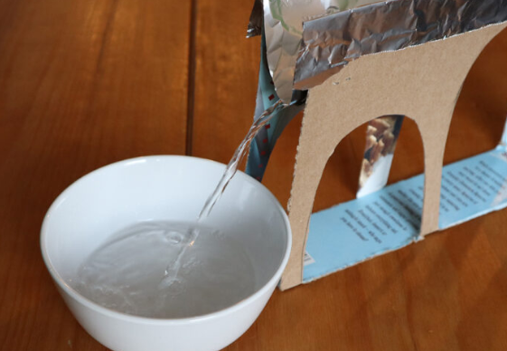 | Compare products based on design criteria and performance  Critically reflect on their design and suggest improvements  Evaluate how well the product meets the needs of the intended user | Understand mechanical systems in more depth (e.g. cams, pulleys)  Use electrical systems with switches and bulbs in functional products  Apply computing to control or monitor their products (basic programming)  Night Light  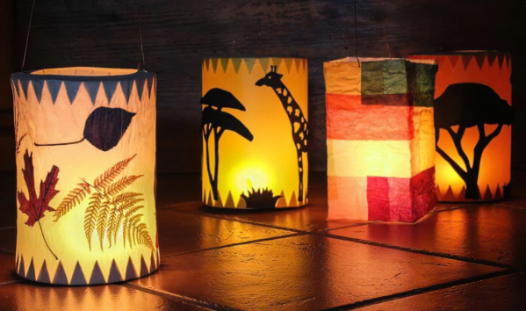 | Know where and how a variety of ingredients are grown, reared and caught.  Follow recipes to prepare dishes safely and hygienically  Use tools and techniques with increasing confidence  Seasonal Soup  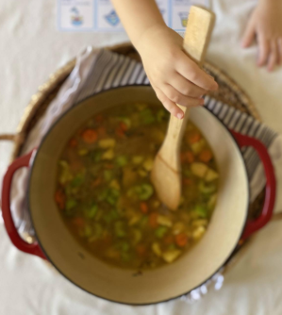
Year 5 | Carry out detailed research into user needs and wants  Develop annotated designs considering function and appearance  Plan the production process and order of work | Use tools and equipment with precision  Work with a variety of materials and components (wood, textiles, electrical)  Modify products in response to testing and feedback  Viking Long ships  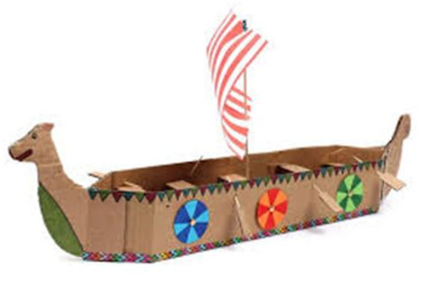 | Evaluate products for purpose, function, and user satisfaction  Use technical vocabulary to discuss and critique products  Consider sustainability and environmental impact | Understand and use more complex mechanical systems (e.g. gears, pulleys)  Incorporate sensors and motors into their designs (if using microcontrollers like Crumble/Arduino)  Using computing and electronics to control a product (e.g. a timed light)  Planetary Day/Night Cycle  (Using Crumble)  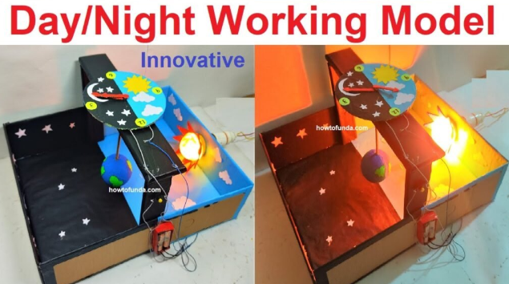 | Prepare and cook savoury dishes using various cooking techniques  Understand seasonality and how to choose ingredients accordingly  Discuss how to make healthy, cost effective food choices  Science is Sweet!  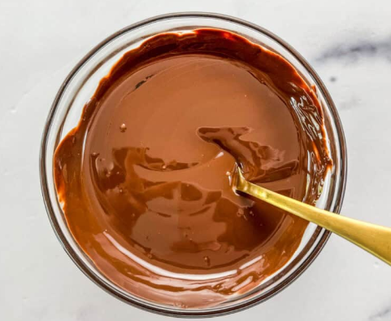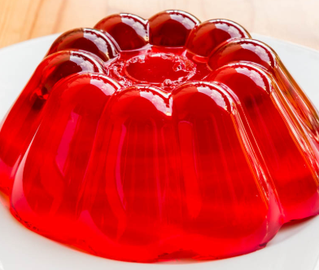  Melting and solidifying (Chocolate or honey cereal cakes), dissolving and setting (Jelly with fruit layers) evaporating and cooking (Fruit compote with yogurt), Irreversible change (Baked banana oat muffins)
Year 6 | Generate, develop and communicate ideas through discussion, sketches, diagrams and porotypes  Justify design choice based on audience, purpose and function  Use market research and user feedback to inform product development | Apply a high level of precision when measuring and cutting  Use complex techniques confidently (e.g. stitching, soldering, joining mechanisms)  Take responsibility for tool use and material selection  Pyjamas for Heart surgery patients  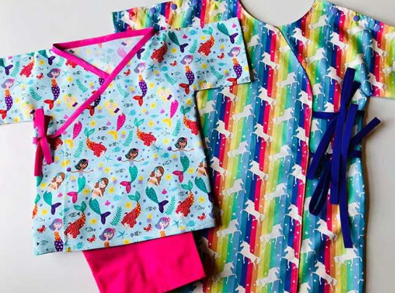 | Evaluate their products against design criteria and the need of the end-user  Identify ways to improve both their product and design process  Critically assess commercial products and understand how design affects functionality | Design and build more sophisticated mechanical or electrical systems  Using computing effectively to control products or simulate function  Demonstrate understanding of design constraints (materials, tools and safety)  Board Game with electronic features (Crumble or Microbit)  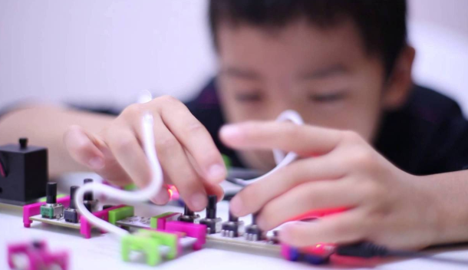 | Create a dish independently from planning to preparation  Demonstrate awareness of food origins, nutrition and cooking techniques  Understand the impact of diet on health  War Time Recipes  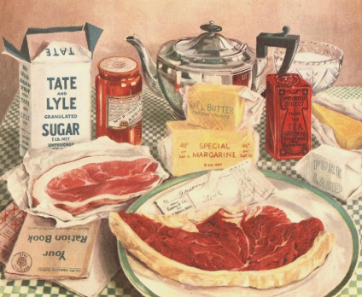  Carrot Cookies (Victory Biscuits)  Mock Apple Pie  Potato based dishes

