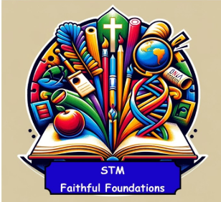 | Geography | Key Vocabulary
Knowledge Organiser | Europe - Greece/Islands  Locational Knowledge  - Locate Europe and Greece on a world map and globe  - Identify Athens, major islands (e.g. Crete, Rhodes), and the Mediterranean Sea  - Use atlases and digital maps to find cities, countries, and regions  - Understand latitude, longitude, and hemispheres  Place Knowledge  - Compare a UK region with a region in Greece  - Explore differences in:  - Climate (mild vs. hot and dry)  - Homes and buildings  - Jobs and transport  - Tourism and culture  Human and Physical Geography  - Describe and understand:  - Physical features: mountains, beaches, islands, seas  - Human features: cities, ports, farms, tourist resorts  - Study how climate and landscape affect life in Greece  - Explore ocean pollution and its impact on coastal areas  Geographical Skills and Fieldwork  - Use maps, atlases, globes, and digital mapping tools  - Use compass points and grid references  - Observe and record features using:  - Sketch maps  - Plans  - Graphs  - Digital technology | Key Vocabulary  - Continent – A large area of land (Europe is a continent)  - Country – A nation with its own government (Greece is a country in Europe)  - Capital City – The main city where the government is based (Athens)  - Mediterranean – The sea surrounding southern Europe  - Climate – The usual weather in a place  - Tourism – People travelling to visit places  - Urban/Rural – City areas vs. countryside
 | History | Key Vocabulary
Knowledge Organiser | Ancient Greeks  Chronological Understanding  - Place Ancient Greece on a timeline using BC/AD  - Understand that Ancient Greece existed over 2,000 years ago  - Compare life in Ancient Greece with other time periods  Historical People and Events  - Alexander the Great – A famous Greek leader and conqueror  - Learn about:  - Greek gods and goddesses  - The Olympic Games  - Daily life in Athens and Sparta  - Greek myths and legends  Historical Enquiry and Evidence  - Ask questions like:  - “What was life like in Ancient Greece?”  - “Why do we still learn about the Greeks?”  - Use sources such as:  - Artefacts  - Buildings  - Written accounts  - Images and maps  - Understand that sources can show different views  Historical Significance  - Ancient Greece is important because:  - It introduced ideas like democracy, philosophy, and theatre  - It influenced modern language, buildings, and sports  - It helps us understand how people lived and thought in the past | Key Vocabulary  - Ancient – From a very long time ago  - Civilisation – A group of people with an organised society and culture  - Democracy – A system where people vote to make decisions  - Philosopher – A person who thinks deeply about life and knowledge  - Olympics – Sporting games started in Ancient Greece  - Myth – A traditional story, often involving gods or heroes  - City-state – A city that ruled itself, like Athens or Sparta

