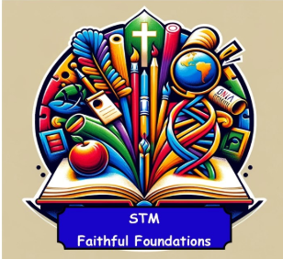 | Geography | Key Vocabulary
Knowledge Organiser | Locational Knowledge  - The world is made of land and water  - Begin to name some continents and oceans  - Recognise the UK and locate it on a map  - Identify the Arctic (North Pole) and Antarctic (South Pole) on a globe  Place Knowledge  - Compare the Arctic and Antarctic with the UK  - Notice differences in weather, clothing, and homes  - Talk about what life is like in cold places using pictures and videos  Human and Physical Geography  - Use words like: ice, snow, cold, windy, sea, mountains  - Understand how weather affects life (e.g. clothing, travel)  - Recognise oceans, seas, rivers, and lakes on a map  - Learn the difference between fresh water and salt water  Geographical Skills and Fieldwork  - Use world maps, atlases, and globes  - Use simple compass directions (North, South, East, West)  - Match aerial photos to real places  - Create simple maps with symbols and keys  - Use positional language (e.g. next to, behind) | Key Vocabulary  - Continent – A large area of land (e.g. Antarctica)  - Ocean – A large body of salt water (e.g. Arctic Ocean)  - North Pole – The top of the Earth, in the Arctic  - South Pole – The bottom of the Earth, in Antarctica  - Iceberg – A large piece of ice floating in the sea  - Glacier – A slow-moving river of ice  - Polar – Very cold areas near the North and South Poles  - Weather – What the sky and air are like (e.g. snowy, windy)
 | History | Key Vocabulary
Knowledge Organiser | Arctic Explorers – Focus on Robert Falcon Scott  Chronological Understanding  - Use words like “a long time ago”, “in the past”, “years ago”  - Place Robert Scott’s expedition on a simple timeline  - Understand that Scott lived and explored over 100 years ago  Historical People and Events  - Robert Falcon Scott was a British explorer  - He led expeditions to the Antarctic  - He tried to be the first person to reach the South Pole  - He and his team faced extreme cold and danger  - He is remembered for his bravery and determination  Historical Enquiry and Evidence  - Ask questions like:  - “Who was Robert Scott?”  - “What was it like to explore the Antarctic?”  - Use photos, artefacts, videos, and stories to learn about the past  - Understand that people in the past lived and travelled very differently  Historical Significance  - Robert Scott is remembered because:  - He was a brave explorer  - He helped people learn more about the Antarctic  - His story teaches us about courage and teamwork  - Understand what makes someone important in history | Key Vocabulary  - Explorer – A person who travels to new places to discover things  - Expedition – A journey made for a special reason  - Arctic – The area around the North Pole  - Antarctic – The area around the South Pole  - Ice Age – A time when much of the Earth was covered in ice  - Past – Something that has already happened  - Timeline – A way to show events in the order they happened

